Sozo History:
Sozo International began in 2002, in response to the opportunity presented by the liberation of Afghanistan from Taliban forces, shortly after September 11, 2001.
In 2005, following the Indian Ocean tsunami of Dec. 26, 2004, Sozo began work in Sri Lanka, with communities heavily impacted by the disaster.
Sozo aims to reach the most impoverished people in identifiable communities where war and natural disaster have wreaked havoc.
Sozo aims to provide emergency and ongoing relief for internally displaced people (IDP) and to encourage development with healthcare, education, and economic initiatives aimed at changing the day-to-day existence of people in need as well as providing for their future.


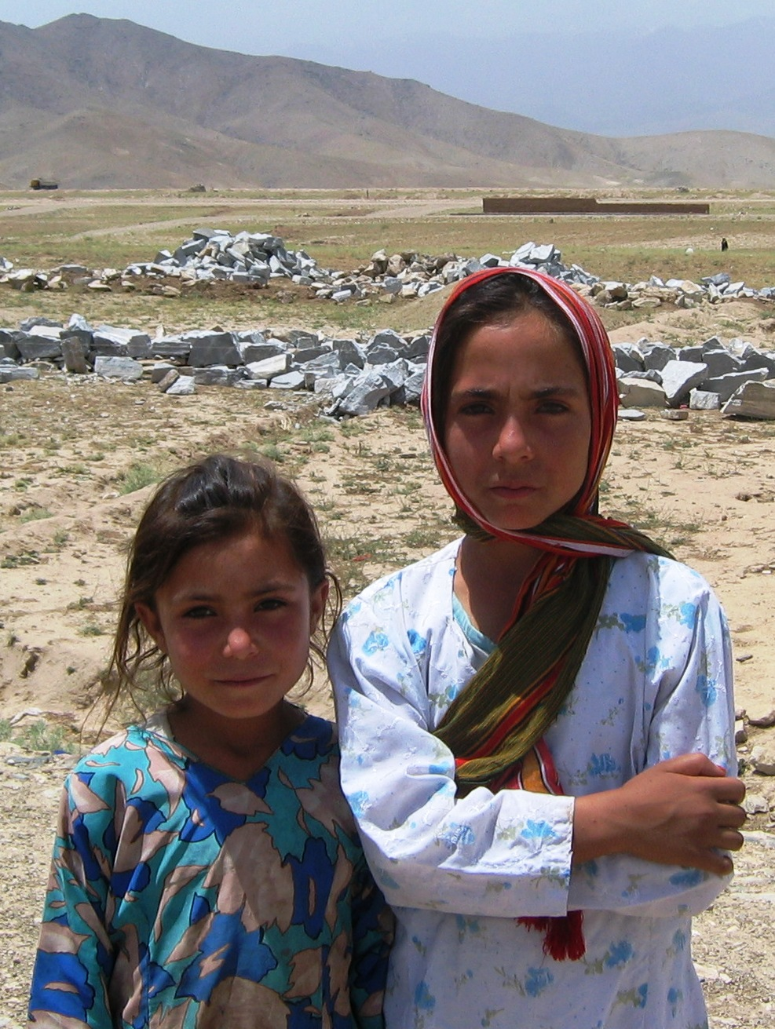
Afghanistan
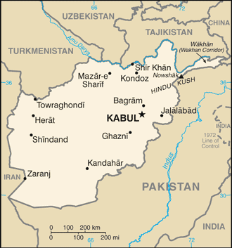

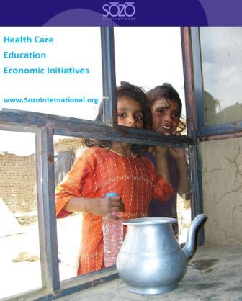

Sozo Communities
Sozo is actively at work in Afghanistan with relief and development, serving in the communities of Istalif, Barek Aub, and Kabul.
Our work begins with relief: food, water, shelter, clothing and more. The process of transformational development continues as we form relationships with the leaders in each community.
Our goal is long-lasting change that is owned by the local people.

Sozo International
PO Box 436967
Louisville, KY 40253
Phone: (502) 253-4308
Fax: (502) 266-6075

House 23, Street 5
Taimani Road
Kabul, Afghanistan
Phone: +93 (0) 700 27 86 33
+93 (0) 752 00 11 20
Email: info@sozointernational.org
www.sozointernational.org
Strengthening communities through transformational development

About Sozo

Sozo International partners with at
risk people to create a sustainable
future and transformed lives through
health, education and economic initiatives.

Healthcare

Sozo works to provide healthcare solutions for communities in some of the poorest and most medically underserved areas. Our focus is not only on treatment, but also on education about health, hygiene, and prevention of disease. Sozo wants to help people help themselves to stay healthy.

Education
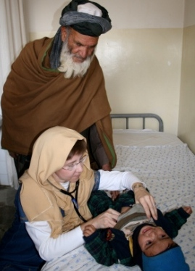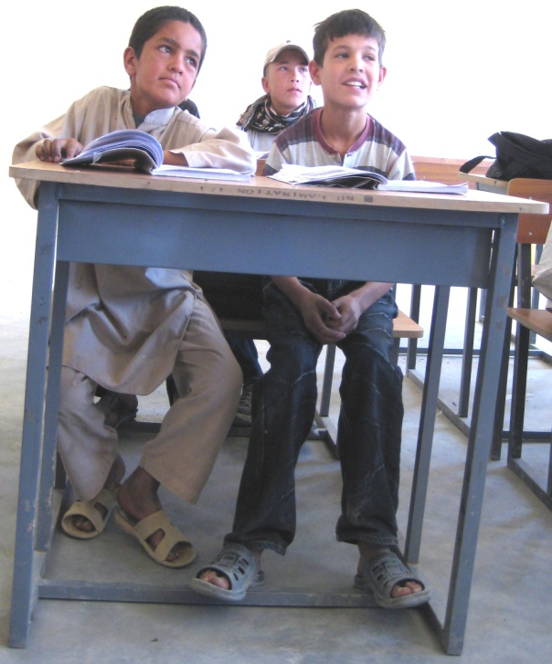 Sozo supports educational initiatives that strengthen communities suffering from a lack of educational opportunities, inadequate facilities, and low levels of literacy. Educational support is a high priority within our communities.

Economic Development
Sozo supports work and training programs that promote sustainability. Sozo supports small business start ups that create economic activity in communities that are lacking. Sozo also provides jobs for nationals who want to assist in relief and development efforts in their own country.

Partnerships
Sozo relies on corporate and individual partners to fund the relief and development work in Afghanistan. In addition, Sozo collaborates with other NGOs, the military, and the governments of Afghanistan and the United States. 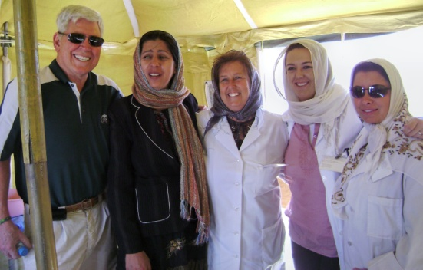
Sozo
Board of Directors
Ben Thornley, Bob Tunnell, Chris Hadley, Diane Cornwell, Jim Burgen, Mary Plese, Ron Barnes
Advisory Board
Dr. LeRoy Lawson, Dr. Paul Cedar, Steve Saint
Afghanistan Staff
Abdul Wakil, National Director
Mohammed Khan, Assistant National Director
Sozo also employs approximately one hundred Afghan nationals serving in the Sozo guesthouse, providing office support, transportation, security assistance, and medical services in the Kabul province.
U.S. Staff
Len Stitt, Executive Director
Lesli Sweeney, Field Advocate
Charles McKibben, Accountant

